**Before a Wildfire or Poor Air Quality Event**

**Preparation Checklist:**

1. **Stay Informed:**
   * Sign up for local emergency alerts.
   * Monitor weather reports and air quality indexes (AQI) using apps like AirNow and AQICN.
2. **Home Preparedness:**
   * Install smoke detectors on every level of your home.
   * Ensure all windows and doors are properly sealed.
   * Use weather stripping or caulking to close gaps.
   * Keep an air purifier with a HEPA filter in your home.
3. **Emergency Kit (Go Bag):**
   * Pack an emergency kit including:
     + N95 masks
     + Medications (2-week supply)
     + First aid kit
     + Bottled water (1 gallon per person per day for at least 3 days)
     + Non-perishable food
     + Flashlight and batteries
     + Battery-powered radio
     + Important documents (identification, insurance, medical records)
     + Cell phone chargers
     + Personal hygiene items

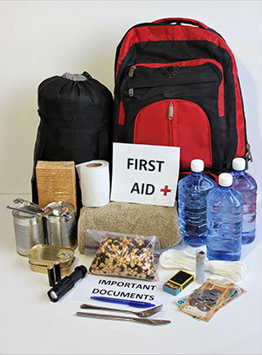

1. **Evacuation Plan:**
   * Create and practice a family evacuation plan.
   * Know multiple routes out of your neighborhood.
   * Identify a meeting point for your family.
2. **Vehicle Preparedness:**
   * Keep your car’s gas tank at least half full.
   * Have an emergency kit in your car.
   * Keep a map of the area and evacuation routes.